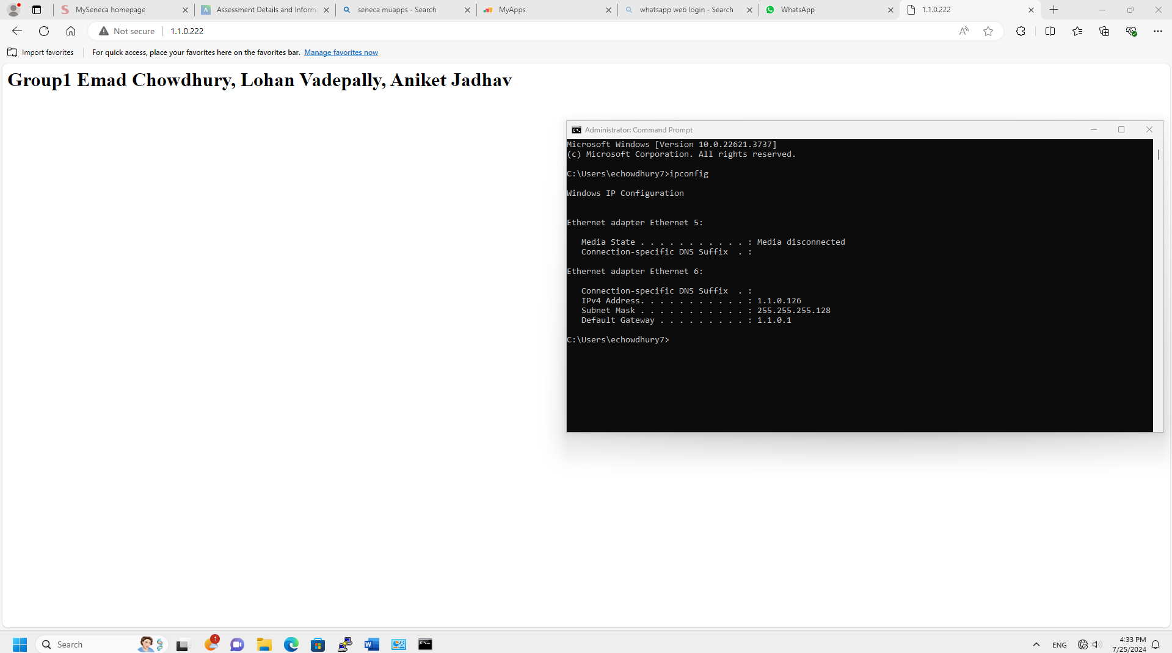
Web browser

Task 2 ss1
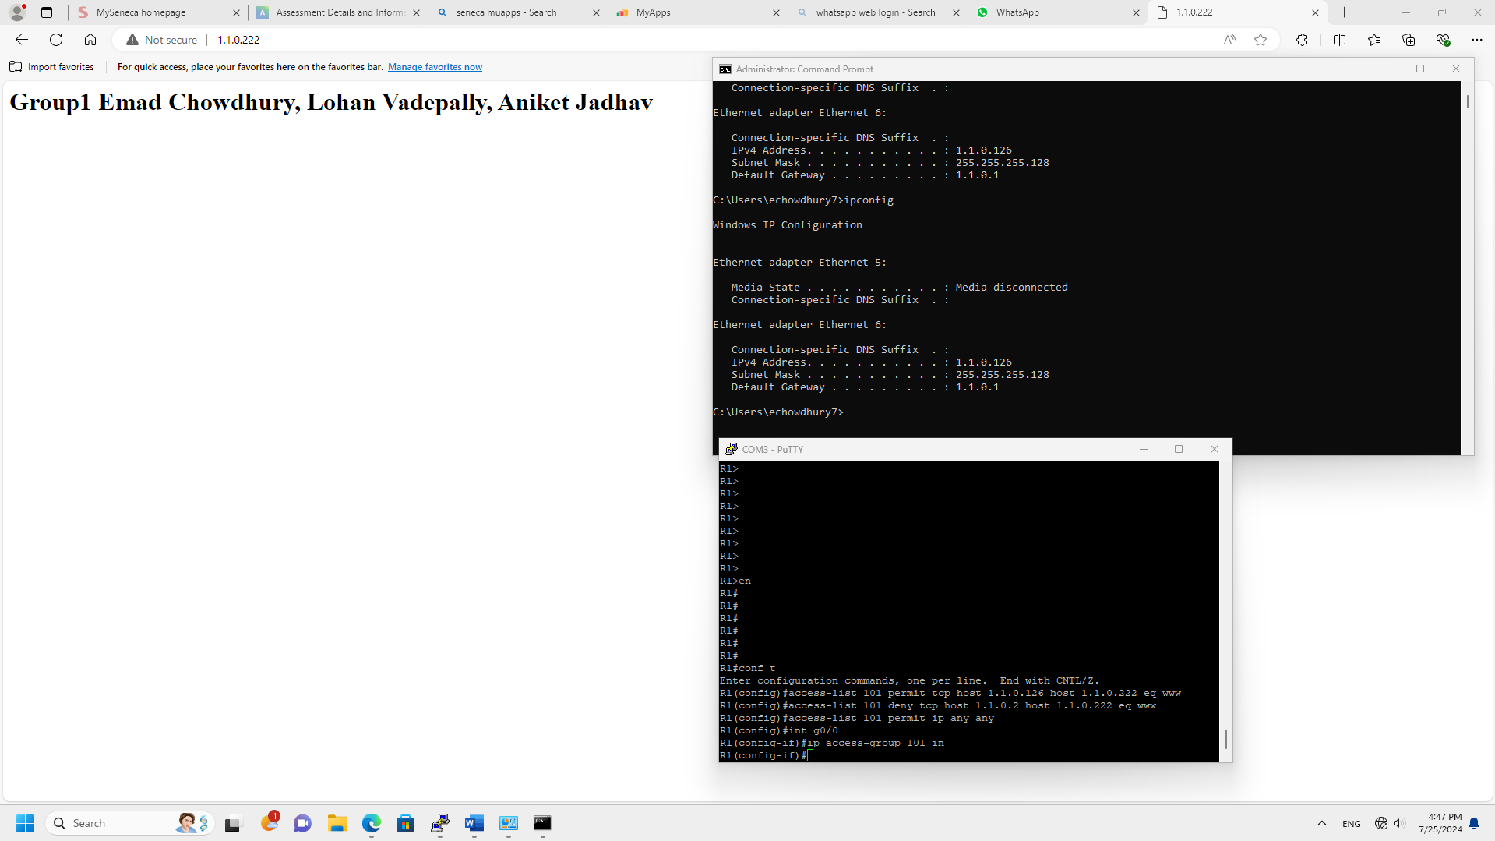

Task 2 ss 2

Task 3 sss1
